Unit 3 Assignment: Natural Language Processing

Shubham Raj
Purdue University Global
IN404: Machine Learning
September 2026

1. Python Program Execution
I completed the provided IN404_Unit3.py program by filling in all the sections marked with "YOUR CODE HERE." The program performs the following operations on the IN404_Reviews.csv data set:
- Reads the CSV file and displays the first five rows and dimensions (958 rows, 8 columns).
- Replaces NaN values with "none" to handle missing data.
- Applies sentiment analysis using TextBlob to create a new "sentiment" column (expanding to 9 columns).
- Filters the data set to only include rows with actual review text (363 rows remain).
- Generates a boxplot of sentiment grouped by star rating and a histogram of sentiment distribution.
- Displays the most positive reviews (sentiment = 1.0) and most negative reviews (sentiment < −0.66).
- Identifies sentiment outliers: negative sentiment in 5-star reviews and positive sentiment in 1-star reviews.
- Splits the data into training (75%) and testing (25%) sets using train_test_split with random_state=1.
- Applies three count vectorization models with logistic regression, reporting accuracy for each.
- Calculates the null model accuracy as a baseline comparison.

The completed .py file and the IN404_Unit3.txt results file are submitted alongside this document. Below is a screenshot of the program execution output:

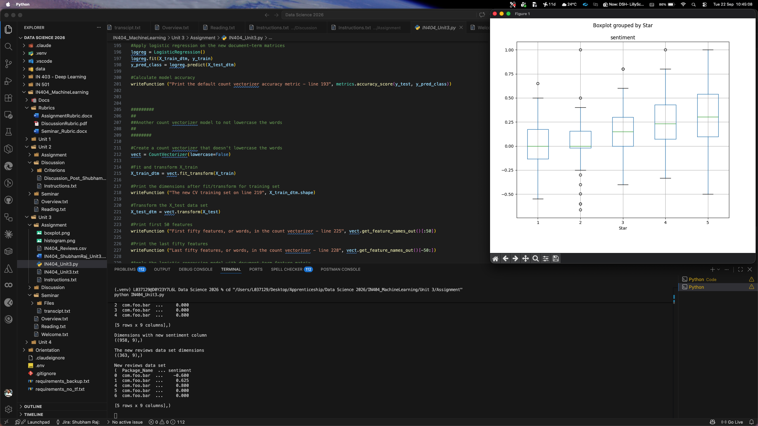

2. Boxplot Visualization of Sentiment Grouped by Star Ratings

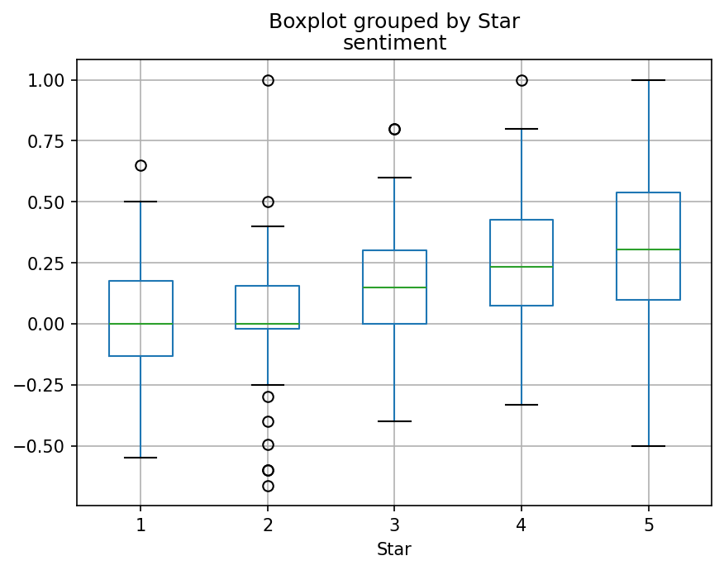

The boxplot above displays the distribution of sentiment polarity scores grouped by star rating (1 through 5). The sentiment polarity ranges from −1.0 (most negative) to +1.0 (most positive), as calculated by the TextBlob library.
Several key observations emerge from this visualization. First, there is a general upward trend in median sentiment as the star rating increases. For 1-star and 2-star reviews, the median sentiment sits near 0.00 (neutral), while for 3-star reviews it rises to approximately 0.15, and for 4-star and 5-star reviews it increases further to approximately 0.23 and 0.30, respectively. This confirms the intuitive expectation that higher-rated reviews tend to contain more positive language.
Second, there is significant overlap between the boxes across star ratings. The interquartile ranges of 1-star and 5-star reviews both extend into the same sentiment territory (roughly 0.0 to 0.25). This overlap tells me that sentiment polarity alone is not a reliable predictor of star ratings. A review with a polarity of 0.15 could easily belong to any star category from 1 to 5.
Third, outliers are visible in nearly every group. For example, 2-star reviews have outliers reaching up to 1.0 (maximum positive), and 4-star and 5-star reviews have outliers reaching down into negative territory. These outliers represent cases where the tone of the written text does not match the numerical star rating the reviewer selected—a key reason why machine learning models beyond simple sentiment analysis are needed to predict star ratings accurately.

3. Histogram Visualization of Sentiment

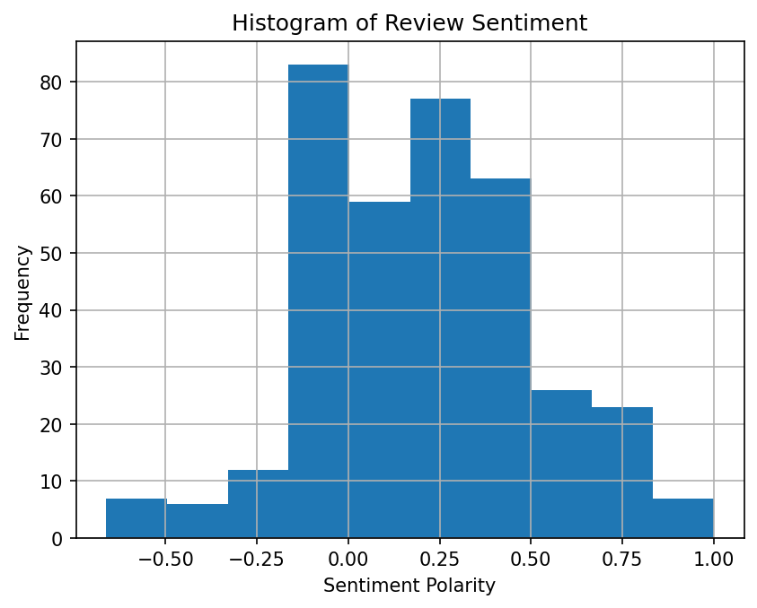

The histogram above shows the frequency distribution of sentiment polarity scores across all 363 reviews that contained actual text. The x-axis represents the sentiment polarity (ranging from −1.0 to +1.0), and the y-axis represents the count (frequency) of reviews falling into each bin.
The distribution is right-skewed (positively skewed), with the tallest bar centered near 0.0 (approximately 83 reviews). This indicates that a large portion of reviews have neutral sentiment—their text does not lean strongly positive or negative. The second-tallest cluster falls in the 0.15 to 0.35 range (approximately 77 reviews), representing mildly positive reviews.
Very few reviews fall below −0.25 on the polarity scale, and only a small number reach the extreme positive end (0.75 to 1.0). This tells me that most reviewers write in moderate, measured language regardless of their actual star rating. The dominance of neutral-to-slightly-positive sentiment explains why sentiment polarity alone cannot distinguish well between the five star categories, reinforcing the need for count vectorization and logistic regression models that analyze the actual word content rather than relying solely on an overall tone score.

4. Accuracy Model Results
The four model accuracy results from my execution are:
Model | Accuracy
Model 1: Default Count Vectorizer | 0.3956 (39.56%)
Model 2: No-Lowercase Count Vectorizer | 0.4176 (41.76%)
Model 3: N-gram (1–3) Count Vectorizer | 0.4286 (42.86%)
Null Model | 0.6044 (60.44%)

4.1 Description of Count Vectorization
Count vectorization is a text-processing technique that converts a collection of text documents into a numerical matrix called a document-term matrix (DTM). Each row in the matrix represents a document (in this case, a review), and each column represents a unique word (or token) found across all documents. The cell values contain the count of how many times each word appears in each document.
Count vectorization is used in machine learning because algorithms like logistic regression require numerical input—they cannot process raw text directly. By converting text into a matrix of word counts, we create features (the X variables) that the model can use to learn patterns and make predictions. In our case, the count vectorizer turns each review into a row of numbers representing how many times each word in the vocabulary appears in that review.

4.2 Description of the Three Count Vectorization Models
Model 1 – Default Count Vectorizer: This model uses the default settings of sklearn's CountVectorizer. It converts all words to lowercase, tokenizes the text into individual words, and counts each word's occurrence. The training set produced a matrix with dimensions 272 × 1,534, meaning 272 training reviews and 1,534 unique words. After applying logistic regression, this model achieved an accuracy of 39.56%.
Model 2 – No-Lowercase Count Vectorizer: This model was created with the parameter lowercase=False, meaning it treats uppercase and lowercase versions of the same word as different features. For example, "Love" and "love" become two separate columns. This expanded the feature set to 1,751 unique tokens (versus 1,534 in Model 1). After applying logistic regression, this model achieved an accuracy of 41.76%, a slight improvement over Model 1.
Model 3 – N-gram (1–3) Count Vectorizer: This model was created with the parameter ngram_range=(1, 3), which means it considers not just individual words (unigrams) but also two-word combinations (bigrams) and three-word combinations (trigrams). For example, in addition to "great" and "app," it also captures "great app" and "great app helped." This dramatically expanded the feature matrix to 272 × 13,863 features. After applying logistic regression, this model achieved the highest accuracy at 42.86%.

4.3 Highest Accuracy
Among the three count vectorization models, Model 3 (N-gram 1–3 Count Vectorizer) had the highest accuracy at 42.86%. This is because using multi-word phrases (bigrams and trigrams) captures more context than individual words alone. Phrases like "does not work" carry meaning that the individual words "does," "not," and "work" cannot convey separately.

4.4 Lowest Accuracy
Model 1 (Default Count Vectorizer) had the lowest accuracy at 39.56%. This model only used individual lowercase words as features, giving it the smallest feature set (1,534 features) and the least contextual information to work with.

4.5 Null Model Description
A null model (also called a baseline or dummy model) is a simple model that makes predictions without actually learning from the features. In this assignment, the null model works by converting star ratings into a binary classification: 5-star versus not-5-star. It then always predicts the most common class in the test set.
The null model accuracy was 60.44%, meaning that if I simply guessed "not 5-star" for every review, I would be correct 60.44% of the time. This serves as a critical baseline for evaluating our count vectorization models. Although our best model (42.86%) appears low in absolute terms, it is important to note that the null model uses a binary split (5-star vs. not), while our logistic regression models predict across all five star categories (1 through 5). The null model demonstrates that a naive approach can achieve seemingly high accuracy by exploiting class imbalance, which is why it is used as a sanity check—any useful model should ideally outperform this baseline when evaluated on the same classification task.

5. Train/Test Split Explanation
The following code was used in the Python program:
X = new_reviews.Review_Text
y = new_reviews.Star
writeFunction("Number of star ratings", y.value_counts())
X_train, X_test, y_train, y_test = train_test_split(X, y, random_state=1)

The train/test split is a fundamental technique in machine learning that divides a data set into two separate subsets: a training set and a testing set. The purpose is to evaluate how well a model generalizes to new, unseen data rather than simply memorizing the training examples.
In this code, X represents the features (the Review_Text column containing the actual review text), and y represents the target variable (the Star column containing the star ratings 1–5). The function train_test_split from sklearn splits both X and y into four components:
- X_train – The review texts used to train the model (approximately 75% of the data, or 272 reviews).
- X_test – The review texts held back to test the model (approximately 25% of the data, or 91 reviews).
- y_train – The corresponding star ratings for the training reviews.
- y_test – The corresponding star ratings for the testing reviews.
The parameter random_state=1 ensures that the random shuffling and splitting of the data is reproducible. Every time the code is run with random_state=1, the exact same reviews end up in the training and testing sets, which allows for consistent and comparable results across different runs and between classmates.
By training the model on one subset and testing on a different, unseen subset, I can assess whether the model has genuinely learned meaningful patterns rather than simply memorizing the training data. If I trained and tested on the same data, the model could achieve artificially high accuracy through memorization (overfitting) rather than true understanding.

6. Sentiment Polarity and Analysis
The following code was used in the Python program:
TextBlob(review).sentiment.polarity

Sentiment polarity is a numerical measure of the emotional tone expressed in a piece of text. It is calculated on a scale from −1.0 to +1.0, where −1.0 represents the most negative sentiment, 0.0 represents neutral sentiment, and +1.0 represents the most positive sentiment. For example, a review stating "Great program! Helped me a lot!" would produce a positive polarity score (closer to +1.0), while a review stating "Bad design, doesn't work properly" would produce a negative polarity score (closer to −1.0).
Sentiment analysis is the broader process of using natural language processing (NLP) techniques to automatically determine the emotional tone of text. In this assignment, I used the TextBlob library to perform sentiment analysis. The TextBlob library has a pre-trained model that examines the words in each review and assigns a polarity score based on known associations between words and emotional tone. It does not need to be trained on our data set—it comes with built-in knowledge of which words are typically positive, negative, or neutral.
In the code, the detectSentiment function takes each review as input and passes it to TextBlob(review).sentiment.polarity, which returns the polarity score. This function was then applied to every review in the data set using the .apply() method, and the resulting polarity scores were stored in a new column called "sentiment." This allowed me to analyze the relationship between the calculated sentiment and the actual star ratings, revealing that while there is a general correlation (higher stars tend to have higher polarity), the overlap between groups shows that sentiment polarity alone is insufficient for accurate star prediction—hence the need for count vectorization and logistic regression models.

